**HL7 Manual Integration Guide**

**Version History**

| **Version** | **Date Issued** | **Brief Summary of Change** | **Author** |
| --- | --- | --- | --- |
| 1.0 | 29th March 2024 | Initial draft describing for possibility of Generate Private Key and Public for EPIC Integration | Aaditya Tewari |

**HL7 v2.8 Message Documentation for C#**

**Overview**

This documentation provides a comprehensive guide for using the C# SDK to create HL7 v2.8 messages for various patient administration events, including admissions (A01), transfers (A02), and discharges (A03). Our SDK employs a modular architecture, enabling developers to easily integrate and manage these messages within their healthcare applications. Additionally, we support both JSON to HL7 and HL7 to JSON conversions, focusing on the essential segments required for these transactions. Developers have the flexibility to include additional segments as needed, with clear indications of each segment's requirement level (required, optional, repeatable) within the model.

**Key Features**

* **Modular Design:** Independent modules for AdmitVisit (A01), TransferPatient (A02), and DischargeEndVisit (A03), allowing for plug-and-play integration.
* **Conversion Support:** Tools for converting between JSON and HL7 message formats.
* **Customizable:** Options to append additional segments based on specific requirements.
* **Segment Hierarchy:** A well-defined hierarchy of segments within the model for easy reference and implementation.

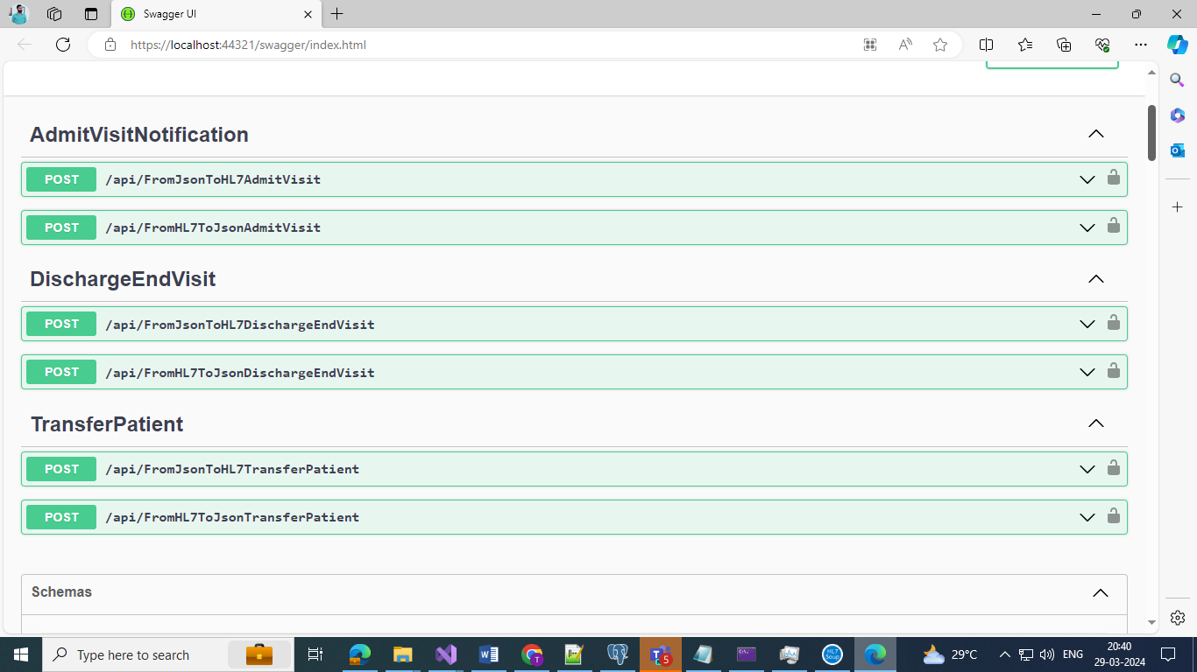

**Getting Started**

**Prerequisites**

* .NET Framework or .NET Core compatible environment.
* C# SDK version 8 or higher.

**Installation**

Ensure the C# SDK is installed and properly configured in your development environment. For specific installation instructions, refer to the SDK's documentation.

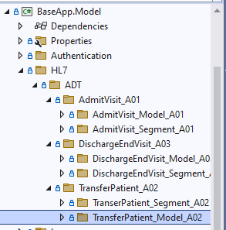

**Implementing HL7 Messages**

**AdmitVisit (A01)**

The AdmitVisit module handles the creation of A01 messages to signal the admission of a patient into a healthcare facility.

* **Required Segments:** MSH, EVN, PID, PV1.
* **Optional/Repeatable Segments:** Refer to the documentation for details.

**TransferPatient (A02)**

TransferPatient facilitates the generation of A02 messages, indicating a patient's transfer within or between facilities.

* **Required Segments:** MSH, EVN, PID, PV1.
* **Optional/Repeatable Segments:** Customization available as per user needs.

**DischargeEndVisit (A03)**

DischargeEndVisit manages A03 messages for marking the end of a patient's visit or stay within a facility.

* **Required Segments:** MSH, EVN, PID, PV2, PV1.
* **Optional/Repeatable Segments:** Developers can append segments based on the requirements.

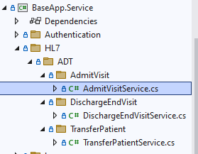

**Conversion Between JSON and HL7**

The SDK provides utilities to convert between JSON and HL7 formats. This feature supports only the essential segments for A01, A02, and A03 messages. Developers can extend the conversion to include additional segments by modifying the provided models.

**JSON to HL7**

Converts JSON-formatted data into an HL7 message string, adhering to the structure and segments defined for the specific message type (A01, A02, A03).

**HL7 to JSON**

Parses an HL7 message string into JSON format, providing a structured and easily manipulable representation of the message data.  
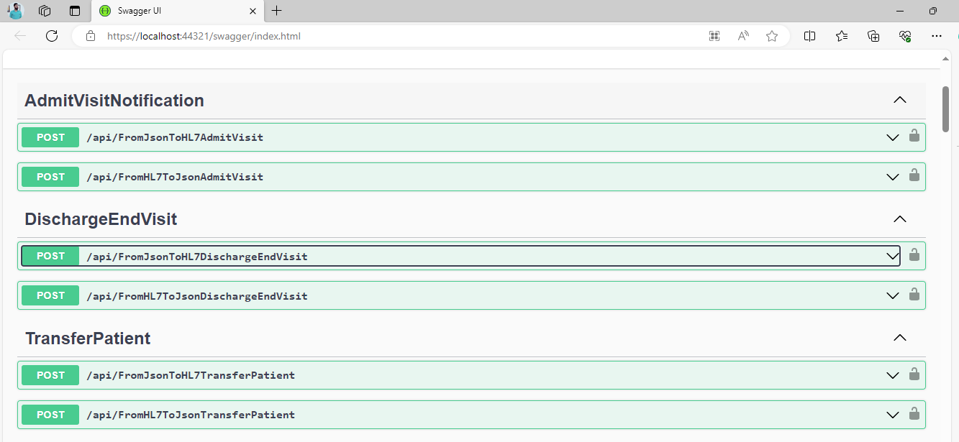

**Extending and Customizing Messages**

Developers can extend messages by appending additional segments as required. The SDK models include tags indicating whether segments are required, optional, or repeatable, aiding in the customization process.

**Reference**

For detailed information on segments and their definitions, please refer to the HL7 v2.8 segments documentation available at [HL7 Definitions](https://hl7-definition.caristix.com/v2/HL7v2.8/Segments?chapters=CH_02,CH_03,CH_04).

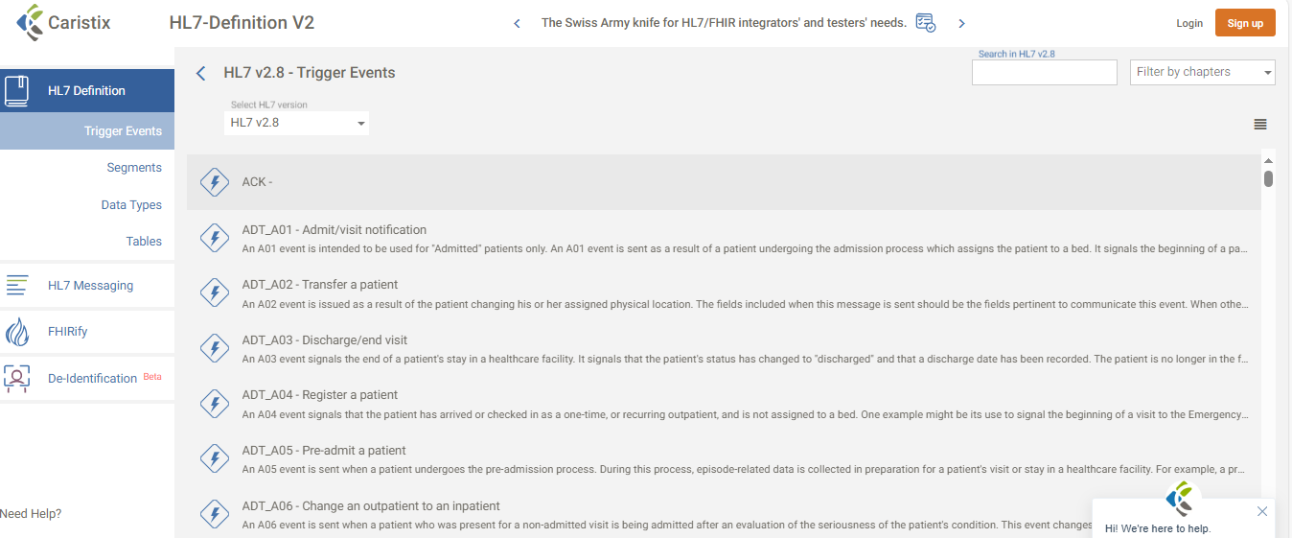

**Note on Lower Version Compatibility**

If you're working with a version of HL7 prior to v2.8, you may need to adjust the segments used in your messages. The provided link to the HL7 Definitions site can be used as a reference to determine which segments are applicable to your specific version. Simply comment out or omit the segments not relevant to your version.

**Conclusion**

This C# SDK offers a flexible and efficient way to manage HL7 v2.8 messages within healthcare applications. By leveraging its modular design, conversion capabilities, and customization options, developers can significantly streamline the integration and handling of patient administration messages.